Chapter Two: Mechanical properties
2022-2023
Dr. Haider Mahdi Lieth
STAGE :2ND YEAR SEMESTER :2ST CODE: ME214

Chapter Two
Mechanical properties
  - introduction
Many materials, when in service, are subjected to forces or loads; examples include the aluminum alloy from which an airplane wing is constructed and the steel in an automobile axle. In such situations it is necessary to know the characteristics of the material and to design the member from which it is made such that any resulting deformation will not be excessive and fracture will not occur. The mechanical behavior of a material reflects the relationship between its response and deformation to an applied load or force. Important mechanical properties are strength, hardness, ductility, and stiffness.
The mechanical properties of materials are ascertained by performing carefully designed laboratory experiments that replicate as nearly as possible the service conditions. Factors to be considered include the nature of the applied load and its duration, as well as the environmental conditions. It is possible for the load to be tensile, compressive, or shear, and its magnitude may be constant with time, or it may fluctuate continuously. Application time may be only a fraction of a second, or it may extend over a period of many years. Service temperature may be an important factor.
Materials and metallurgical engineers, on the other hand, are concerned with producing and fabricating materials to meet service requirements as predicted by these stress analyses. This necessarily involves an understanding of the relationships between the microstructure (i.e., internal features) of materials and their mechanical properties.
Tension Tests
One of the most common mechanical stress–strain tests is performed in tension. As will be seen, the tension test can be used to ascertain several mechanical properties of materials that are important in design. A specimen is deformed, usually to fracture, with a gradually increasing tensile load that is applied uniaxially along the long axis of a specimen. A standard tensile specimen is shown in Figure 1 Normally, the cross section is circular, but rectangular specimens are also used. The standard diameter is approximately 12.8 mm (0.5 in.), whereas the reduced section length should be at least four times this diameter; 60 mm ( in.) is common.
The specimen is mounted by its ends into the holding grips of the testing apparatus (Figure 2). The tensile testing machine is designed to elongate the specimen at a constant rate.
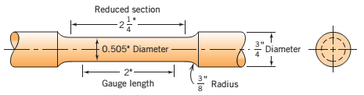
Fig. 1 : standard tensile specimen with circular cross section

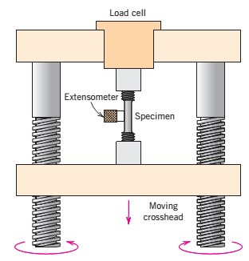
Fig. 2 : tensile test machine

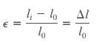

in which is the original length before any load is applied, and is the instantaneous length. Sometimes the quantity is denoted as and is the deformation elongation or change in length at some instant, as referenced to the original length
Compression Tests
Compression stress–strain tests may be conducted if in-service forces are of this type. A compression test is conducted in a manner similar to the tensile test, except that the force is compressive and the specimen contracts along the direction of the stress. Tensile tests are more common because they are easier to perform; also, for most materials used in structural applications, very little additional information is obtained from compressive tests.
Shear and Torsional Tests
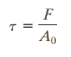
For tests performed using a pure shear force as shown in Figure below , the shear stress is computed according to

where F is the load or force imposed parallel to the upper and lower faces, each of which has an area of A_{o} . The shear strain γ is defined as the tangent of the strain angle , as indicated in the figure 3 . The units for shear stress and strain are the same as for their tensile counterparts.
Torsion is a variation of pure shear, wherein a structural member is twisted in the manner , torsional forces produce a rotational motion about the longitudinal axis of one end of the member relative to the other end. Examples of torsion are found for machine axles and drive shafts, and also for twist drills. Torsional tests are normally performed on cylindrical solid shafts or tubes. A shear stress is a function of the applied torque T, whereas shear strain is related to the angle of twist, in Figure 3.
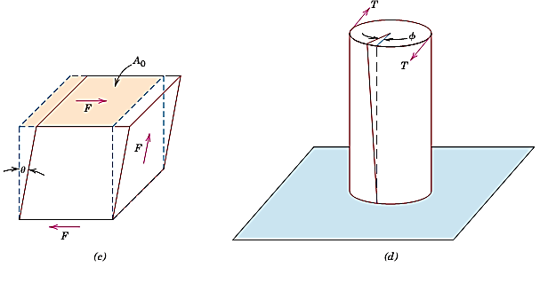
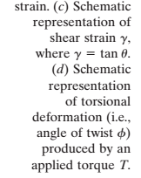
Fig.3

Shear strain: γ= tan θ (×100 %) θ is the strain angle
Torsion: is variation of pure shear. A shear stress in this case is a function of applied torque T, shear strain is related to the angle of twist, φ.

Shear modulus , modulus of rigidity $G=\frac{τ_{xy}}{ϒ_{xy}}=\frac{F/{A_{0}}}{{ΔX}/L}=\frac{FL}{AΔX}$
Shear strain $ϒ=\frac{ΔL}{L}=\tan{ϴ}$
1-2: STRESS–STRAIN BEHAVIOR
In tensile tests, if the deformation is elastic, the stress strain relationship is called Hooke's law:
σ = E ε
E is Young's modulus or modulus of elasticity, has the same units as σ, N/m²or Pa
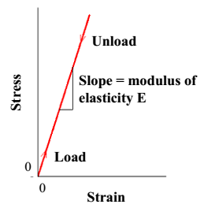
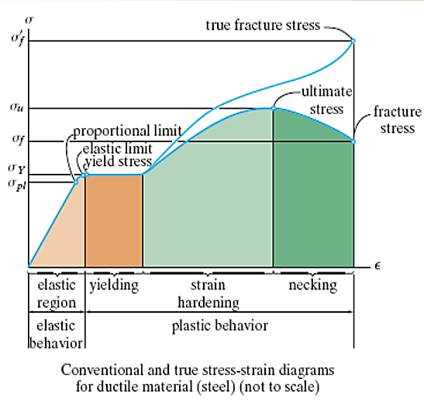

For most typical metals the magnitude of this modulus ranges between 45 GPa ( psi), for magnesium, and 407 GPa ( psi), for tungsten
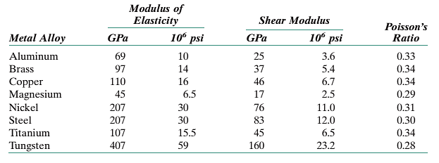
Table 1.1 Room-Temperature Elastic and Shear Moduli, and Poisson’s Ratio for Various Metal Alloys

This modulus may be thought of as stiffness, or a material’s resistance to elastic deformation. The greater the modulus, the stiffer the material, or the smaller the elastic strain that results from the application of a given stress.
Elastic deformation is nonpermanent, which means that when the applied load is released, the piece returns to its original shape. Upon release of the load, the line is traversed in the opposite direction, back to the origin.
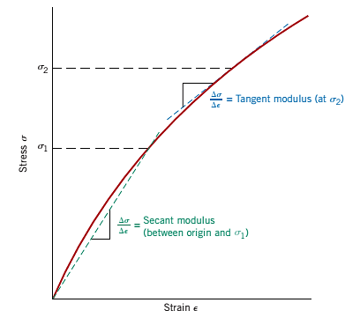
There are some materials (e.g., gray cast iron, concrete, and many polymers) for which this elastic portion of the stress–strain curve is not linear (Figure 4); hence, it is not possible to determine a modulus of elasticity as described above. For this nonlinear behavior, either tangent or secant modulus is normally used. Tangent modulus is taken as the slope of the stress–strain curve at some specified level of stress, while secant modulus represents the slope of a secant drawn from the origin to some given point of the curve. The determination of these moduli is illustrated in Figure 4.
Fig. 4 : stress–strain diagram showing non-linear elastic behavior

ANELASTICITY:- Up to this point, it has been assumed that elastic deformation is time independent—that is, that an applied stress produces an instantaneous elastic strain that remains constant over the period of time the stress is maintained. It has also been assumed that upon release of the load the strain is totally recovered—that is, that the strain immediately returns to zero. In most engineering materials, however, there will also exist a time-dependent elastic strain component. That is, elastic deformation will continue after the stress application, and upon load release some finite time is required for complete recovery. This time-dependent elastic behavior is known as anelasticity, and it is due to time-dependent microscopic and atomistic processes that are attendant to the deformation. For metals the anelastic component is normally small and is often neglected. However, for some polymeric materials its magnitude is significant; in this case it is termed viscoelastic behavior, which is the discussion in polymers chapter.
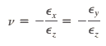
When a tensile stress is imposed on a metal specimen, an elastic elongation and accompanying strain result in the direction of the applied stress (arbitrarily taken to be the z direction), as indicated in Figure 5. As a result of this elongation, there will be constrictions in the lateral (x and y) directions perpendicular to the applied stress; from these contractions, the compressive strains and may be determined. If the applied stress is uniaxial (only in the z direction), and the material is isotropic ( of an object or substance) having a physical property that has the same value when measured in different directions., then A parameter termed Poisson’s ratio is defined as the ratio of the lateral and axial strains, or

For isotropic materials, shear and elastic moduli are related to each other and to Poisson’s ratio according to
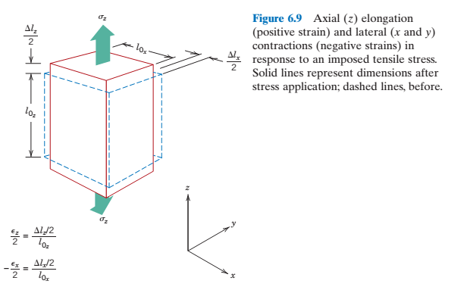
5

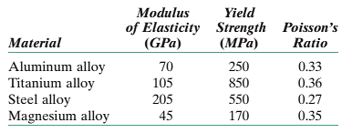
Example 1:- A cylindrical rod 120 mm long and having a diameter of 15.0 mm is to be deformed using a tensile load of 35,000 N. It must not experience either plastic deformation or a diameter reduction of more than 1.2 x10⁻²mm. Of the materials listed blow, which are possible candidates? Justify your choice(s)

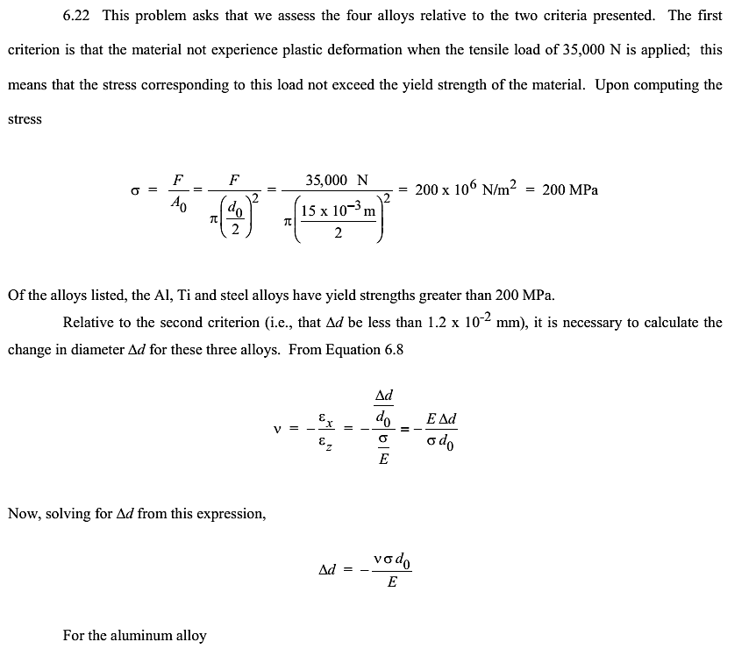
Sol.:

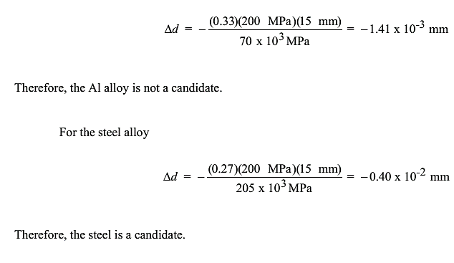

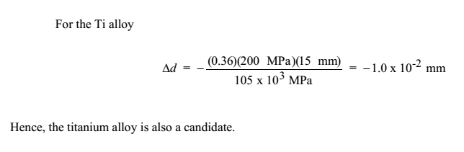

1-3 :- Plastic Deformation:-
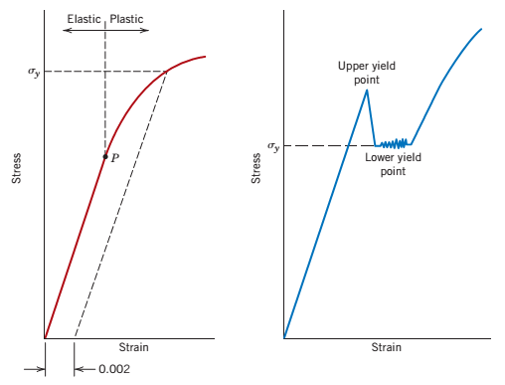
For most metallic materials, elastic deformation persists only to strains of about 0.005. As the material is deformed beyond this point, the stress is no longer proportional to strain (Hooke’s law, to be valid), and permanent, no recoverable, or plastic deformation occurs. Figure 6 a plots schematically the tensile stress–strain behavior into the plastic region for a typical metal.
Fig.6 (a) Typical stress–strain behavior for a metal showing elastic and plastic deformations, the proportional limit P, and the yield strength as determined using the 0.002 strain offset method.
(b) Representative stress–strain behavior found for some steels demonstrating the yield point phenomenon.

stress and strain are not proportional, the deformation is not reversible, deformation occurs by breaking and re-arrangement of atomic bonds (in crystalline materials primarily by motion of dislocations).)
After yielding, the stress necessary to continue plastic deformation in metals increases to a maximum, point M in Figure 7, and then decreases to the eventual fracture, point F. The tensile strength TS(MPa or psi) is the stress at the maximum on the engineering stress–strain curve (Figure 7). This corresponds to the maximum stress that can be sustained by a structure in tension; if this stress is applied and maintained, fracture will result. All deformation up to this point is uniform throughout the narrow region of the tensile specimen. However, at this maximum stress, a small constriction or neck begins to form at some point, and all subsequent deformation is confined at this neck, as indicated by the schematic specimen insets in Figure 7. This phenomenon is termed “necking,” and fracture ultimately occurs at the neck. The fracture strength corresponds to the stress at fracture.

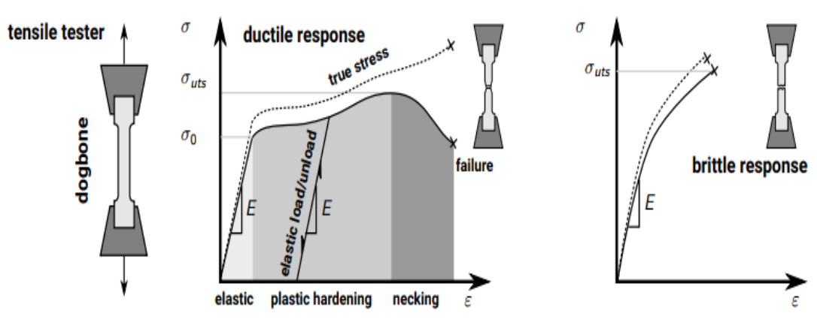

Fig.7 Typical engineering stress– strain behavior to fracture

Ductility is another important mechanical property. It is a measure of the degree of plastic deformation that has been sustained at fracture. A material that experiences very little or no plastic deformation upon fracture is termed brittle. The tensile stress–strain behaviors for both ductile and brittle materials are schematically illustrated in Figure 8.

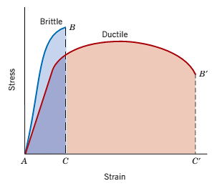
Fig. 8 tensile stress–strain behavior for brittle and ductile materials

Ductility may be expressed quantitatively as either percent elongation or percent reduction in area
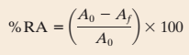
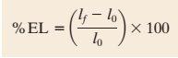

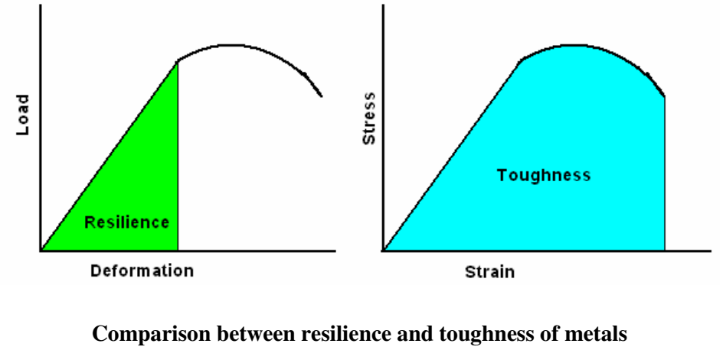
Resilience:- is the capacity of a material to absorb energy when it is deformed elastically and then, upon unloading, to have this energy recovered. The associated property is the modulus of resilience, which is the strain energy per unit volume required to stress a material from an unloaded state up to the point of yielding.

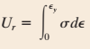
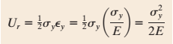

Resilient materials are those having high yield strengths and low moduli of elasticity; such alloys would be used in spring applications.
Toughness it is a measure of the ability of a material to absorb energy up to fracture. Specimen geometry as well as the manner of load application are important in toughness determinations.
1-4 :- TRUE STRESS AND STRAIN:-
True stress is defined as the load F divided by the instantaneous cross-sectional area A_{i} over which deformation is occurring (i.e., the neck, past the tensile point),
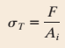

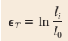
Furthermore, it is occasionally more convenient to represent strain as true strain defined by

If no volume change occurs during deformation—that is, if

true and engineering stress and strain are related according to
$$σ=\frac{Fi}{Ai}$$
$$AiLi=AoLo Ai =\frac{AoLo}{Li}$$
$$σ_{t}=\frac{FiLi}{AoLo}{ σ}_{t}=σ\left(\frac{Lo+∆L}{Lo}\right)$$
$$σ_{t}=σ(1+ϵ)$$
$$∈_{t}=\frac{∆L}{L}=\int_{L0}^{Lf}{\frac{dL}{L}}=\ln{L=\ln{Lf-\ln{Lo=\ln{\frac{lf}{lo}}}}}$$

$$E=\frac{σ}{ϵ}$$
$$∈_{t}=\ln{\frac{L}{Lo}=\ln\left(\frac{Lo+∆L}{Lo}\right)}$$
$$∈_{t}=\ln\left(1+∈\right)$$
Comparison of engineering and true stress–strain behaviors is made in Figure 9. It is worth noting that the true stress necessary to sustain increasing strain continues to rise past the tensile point M.

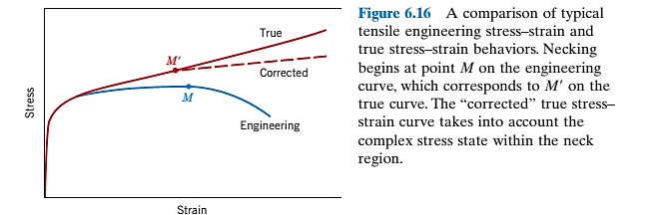
9

For some metals and alloys the region of the true stress–strain curve from the onset of plastic deformation to the point at which necking begins may be approximated by

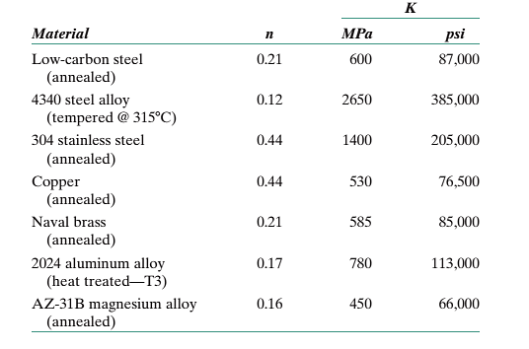
In this expression ,K and n are constants; these values will vary from alloy to alloy, and will also depend on the condition of the material ( whether it has been plastically deformed, heat treated, etc.). The parameter n is often termed the strain hardening exponent and has a value less than unity. Values of n and K for several alloys are contained in Table 1.2.
Table 1.2 Tabulation of n and K Values for Several Alloys
# The strain hardening exponent (n) determines how the metal behaves when it is being formed. Materials that have higher n values have better formability than those with low n values.

Example 2:- For some metal alloy, a true stress of 345 MPa produces a plastic true strain of 0.02. How much will a specimen of this material elongate when a true stress of 415 MPa is applied if the original length is 500 mm (20 in.)? Assume a value of 0.22 for the strain-hardening exponent ,n.
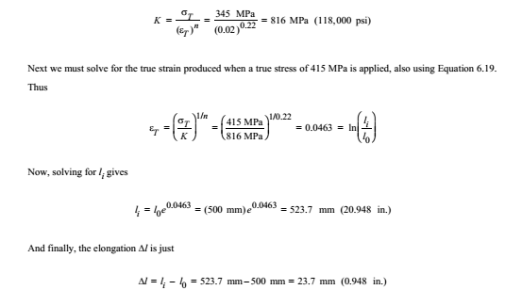

Example 3:- A cylindrical metal specimen having an original diameter of 12.8 mm (0.505 in.) and gauge length of 50.80 mm (2.000 in.) is pulled in tension until fracture occurs. The diameter at the point of fracture is 8.13 mm (0.320 in.), and the fractured gauge length is 74.17 mm (2.920 in.). Calculate the ductility in terms of percent reduction in area and percent elongation.
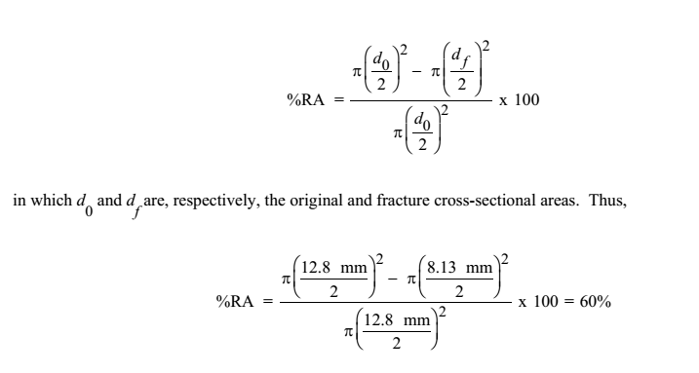

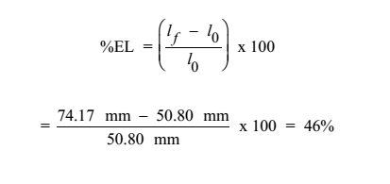

Example 4:- For a brass alloy, the following engineering stresses produce the corresponding plastic engineering strains, prior to necking:
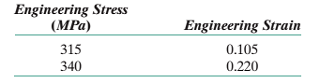

On the basis of this information, compute the engineering stress necessary to produce an engineering strain of 0.28.
Solution :
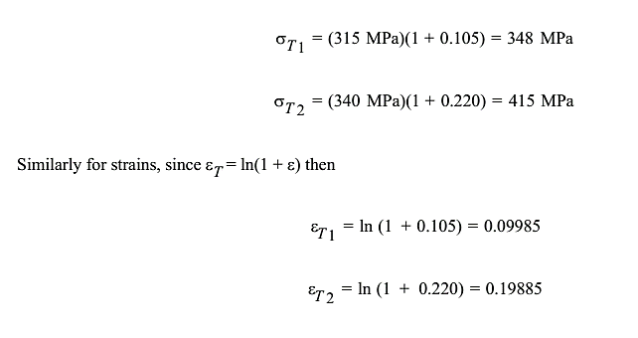

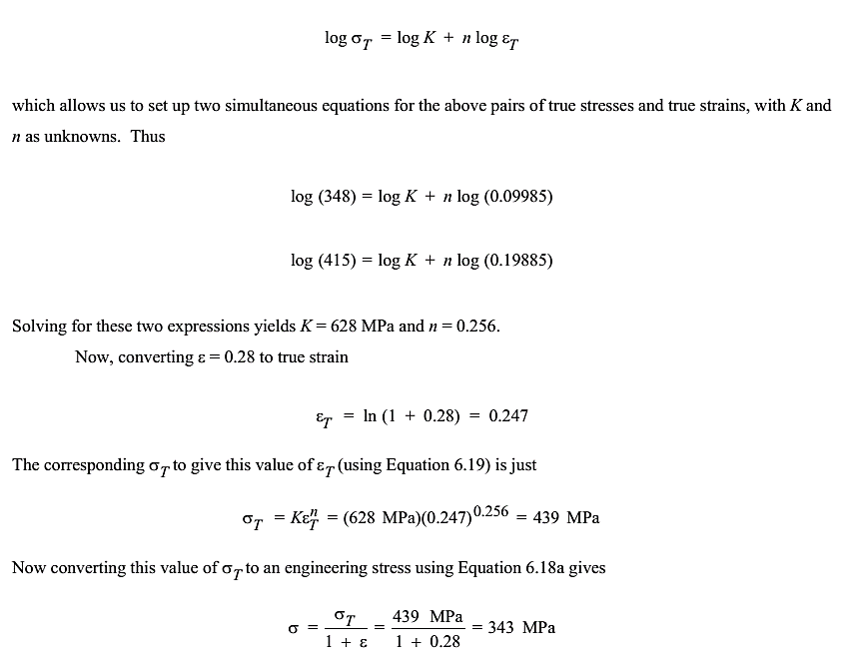

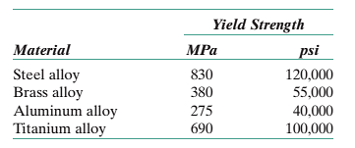
Example 5:- Determine the modulus of resilience for each of the following alloys
Use modulus of elasticity values in Table

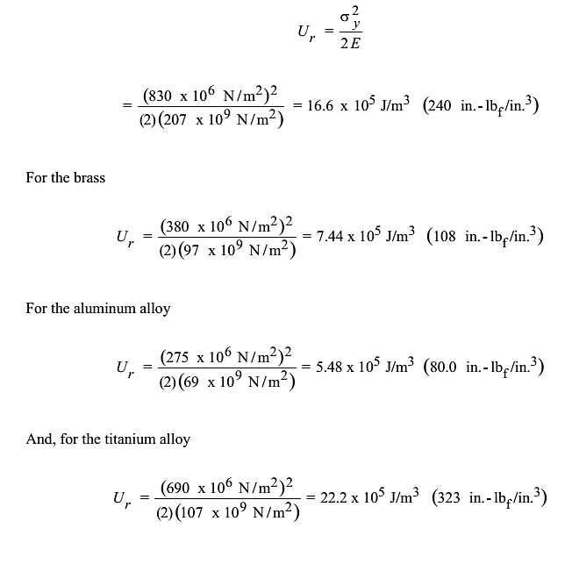

1-5: Hardness: - is a measure of the material’s resistance to localized plastic deformation. Hardness tests can be used for many engineering applications to achieve the basic requirement of mechanical property for examples surface treatments where surface hardness has been much improved, powder metallurgy, fabricated parts: forgings, rolled plates, extrusions, machined parts.
- J.A. Brinell introduced the first standardized indentation-hardness test in 1900. The Brinell hardness test consists in indenting the metal surface with a 10-mm diameter steel ball at a load range of 500-3000 kg, depending of hardness of particular materials.

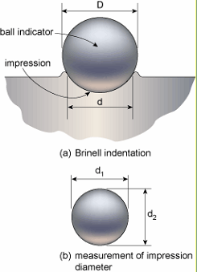
The load is applied for a standard time (~30 s), and the diameter of the indentation is measured.
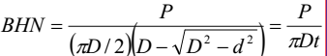

Where
P: is applied load, kg
D: is diameter of ball, mm
d: is diameter of indentation, mm
t : is depth of the impression, mm

Advantages and disadvantages of Brinell hardness test
• Large indentation averages out local heterogeneities of microstructure.
• Different loads are used to cover a wide range of hardness of commercial metals.
• Brinell hardness test is less influenced by surface scratches and roughness than other hardness tests.
• The test has limitations on small specimens or in critically stressed parts where indentation could be a possible site of failure.
- Vickers hardness
• Vickers hardness test uses a square-base diamond pyramid as the indenter with the included angle between opposite faces of the pyramid of 136º.
• The Vickers hardness number (VHN) is defined as the load divided by the surface area of the indentation.
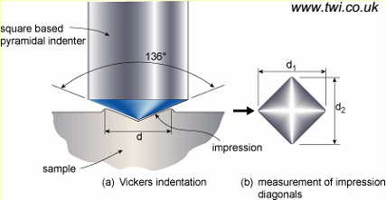
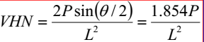

P is the applied load, kg
L is the average length of diagonals, mm
θ is the angle between opposite faces of
diamond = 136º
Note: not widely used for routine check due to a slower process and requires careful surface preparation.
Vickers hardness test uses the loads ranging from 1-120 kgf, applied for between 10 and 15 seconds.
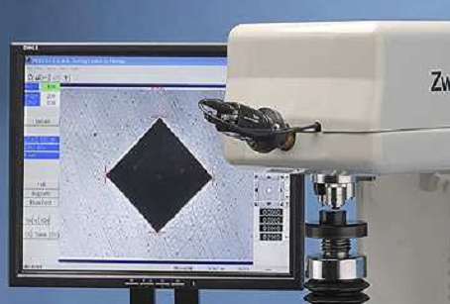
• Provide a fairly wide acceptance for research work because it provides a continuous scale of hardness, for a given load. VHN = 5-1,500 can be obtained at the same load level easy for comparison).

Impressions made by Vickers hardness
• A perfect square indentation (a) made with a perfect diamond pyramid indenter would be a square.
• The pincushion indentation (b) is the result of sinking in of the metal around the flat faces of the pyramid. This gives an overestimate of the diagonal length (observed in annealed metals).
• The barrel-shaped indentation (c) is found in cold-worked metals, resulting from ridging or piling up of the metal around the faces of the indenter. Produce a low value of contact area giving too high value
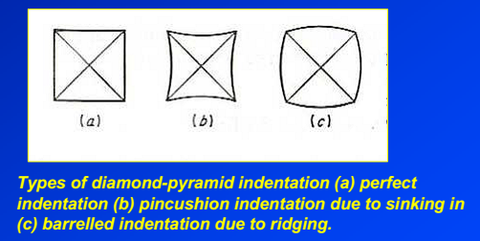

- Rockwell hardness
• The most widely used hardness test in the US and generally accepted due to
1) Its speed
2) Freedom from personal error.
3) Ability to distinguish small hardness difference
4) Small size of indentation.
• The hardness is measured according to the depth of indentation, under a constant load.
Principal of the Rockwell Test
• Position the surface area to be measured close to the indenter.
• Applied the minor load and a zero reference position is established
• The major load is applied for a specified time period (dwell time) beyond zero
• The major load is released leaving the minor load applied.
The Rockwell number represents the difference in depth from the zero reference position as a result of the applied major load.
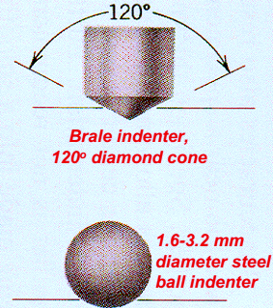

- Micro hardness
• Determination of hardness over very small areas for example individual constituents, phases, requires hardness testing machines in micro or sub-micro scales.
• Vickers hardness can also be measured in a microscale, which is based on the same fundamental method as in a macroscale.
• The Knoop indenter (diamondshape) is used for measuring in a small area, such as at the cross section of the heat-treated metal surface.
• The Knoop hardness number (KHN) is the applied load divided by the unrecovered projected area of the indentation.
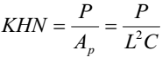

Where P = applied load, kg
Ap= unrecovered projected area of indentation, mm2
L = length of long diagonal, mm
C = a constant for each indenter supplied by manufacturer.
Relationship between hardness and the flow curve
• Tabor suggested a method by which the plastic region of the true stress-strain curve may be determined from indentation hardness measurement.
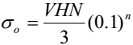
• This is under a condition such that the true strain was proportional to the d/D ratio (ε = 0.2d/D)

Where
σ_{o}: is the 0.2% offset yield strength,kgf.mm⁻²(=9.81 MPa)
VHN: is the Vickers hardness number
N: is the work hardening exponent
For Brinell hardness, a very useful correlation has been used for heat-treated plain-carbon and medium-alloy steels as follows:
• Hardness conversions are empirical relationships for Brinell, Rockwell and Vickers hardness values.
• This hardness conversions are applicable to heat-treated carbon and alloy steels in many heat treatment conditions. (or alloys with similar elastic moduli).
• For soft metals, indentation of hardness depends on the strain hardening behavior of the materials.
• Special hardness-conversion tables for cold-worked aluminum, copper, and stainless steel are given in the ASM Metals Handbook.

Hardness at elevated temperatures
- Hot hardness gives a good indication of potential usefulness of an alloy for high-temperature strength applications.
• Hot hardness testers use a Vickers indenter made of sapphire and with provisions for testing in either vacuum or an inert atmosphere.
• The temperature dependence of hardness could be expressed as follows;
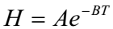

Where
H = hardness, kgf.mm⁻²
T = test temperature, K
A,B = constants

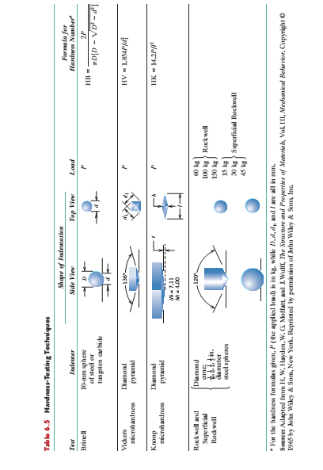

Home work :-
Q1:- The following data were obtained in a tensile test of a low carbon steel of diameter 12 mm and gage length 50 mm
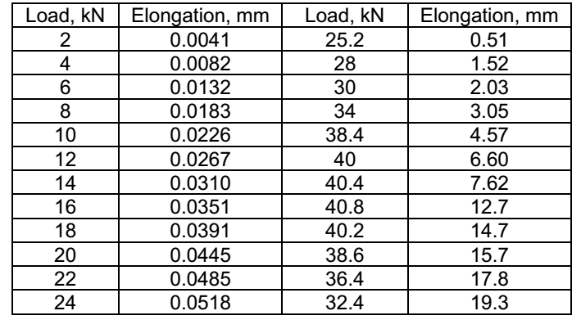

Plot Engineering and True stress-strain curve and find the tensile properties.
- Explain the following :-
1. What is 0.2% proof stress?
2. How is the ductility measured?
3. What is ductile and brittle behavior?
4. What is resilience? What is toughness?
5. What is true stress and strain. Deduce the relationship between true and engineering stress ad strain.
6. Why does the engineering stress-strain curve peak and drop where as the true stress-strain curve keep on going up?
7. What is Poisson's ratio?

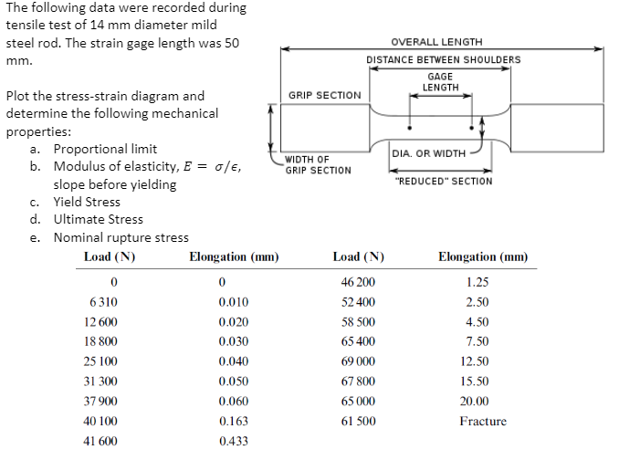
Q2:-

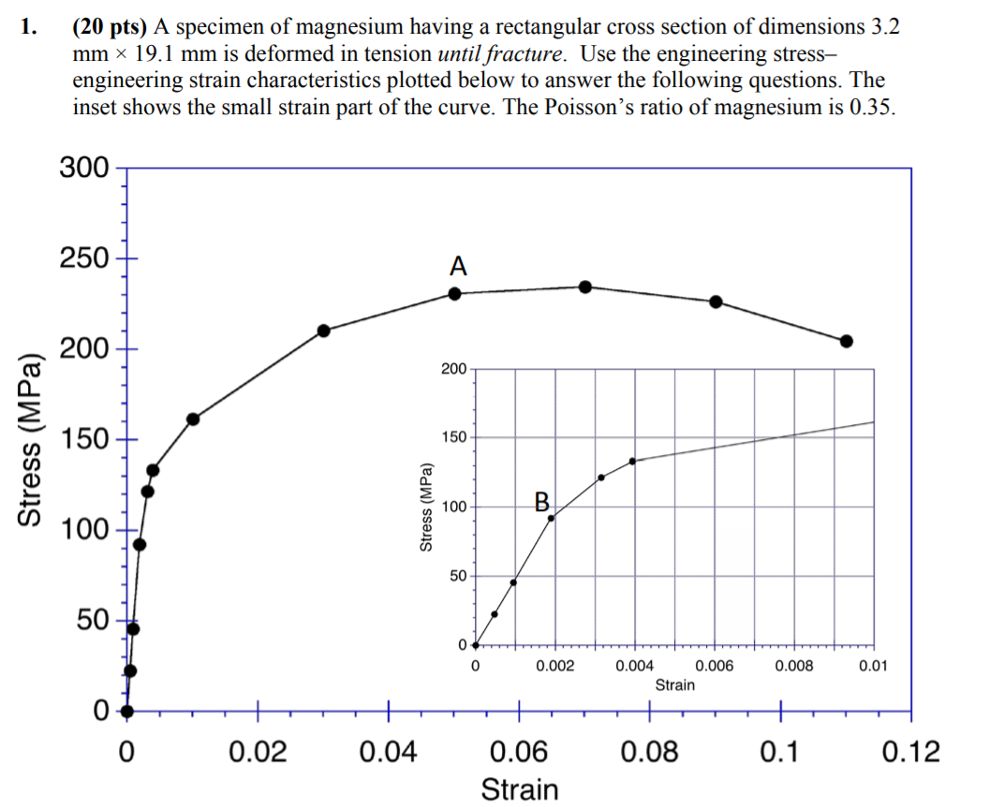
Q3:-

1. What is 0.2% proof stress?
2. calculate the ductility?
3. find the resilience if E=45 Gpa.
4. the %Elongation
5. the engineering stress at fracture
6. the true stress at fracture, and (h) the modulus of resilience.

Q4:-
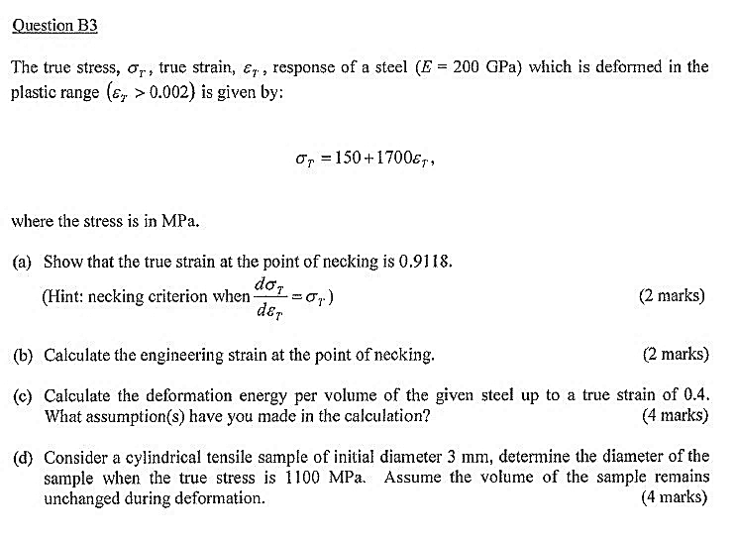

C- calculate the engineering strain at the points of necking
D- find the engineering fracture stress if the total true strain is 1.7

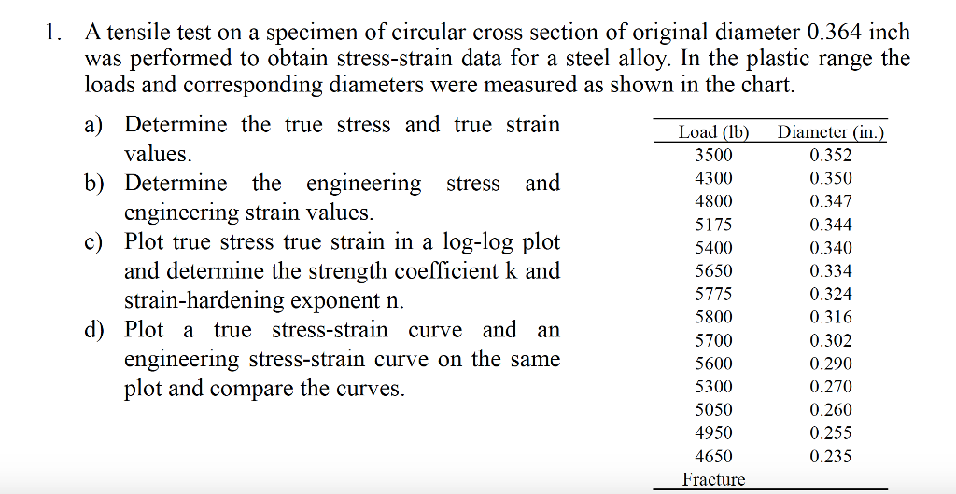
Q5:-

